INTRODUCTION TO CYBERSECURITY

OSI AND NETWORK PROTOCOL
TASK1: Draw the OSI model on paper or using any drawing tool, label all 7 layers, and write one real-world example protocol (like HTTP, TCP, IP, etc.) next to each layer.
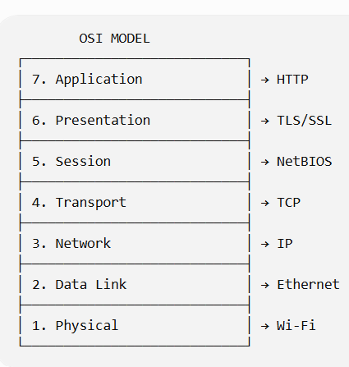
Layer | Name | Example Protocol
7 | Application | HTTP
6 | Presentation | TLS/SSL
5 | Session | NetBIOS
4 | Transport | TCP
3 | Network | IP
2 | Data Link | Ethernet
1 | Physical | Wi-Fi

TASK2: Create a table listing 5 popular apps you use (such as WhatsApp, Instagram, Zomato, Flipkart, Paytm) and for each, identify two network protocols that are likely used when you interact with the app (for example, HTTPS, TCP, UDP, DNS, etc.).
App | Protocol 1 | Protocol 2
WhatsApp | HTTPS | TCP
Instagram | HTTPS | DNS
Zomato | HTTPS | DNS
Flipkart | HTTPS | TCP
Paytm | HTTPS | DNS

- HTTPS is used for secure communication between the app and its servers.
- TCP provides reliable delivery of data.
- DNS helps find the IP address of the required server.
TASK3: Use the command prompt or terminal to run 'ping' and 'tracert' (Windows) or 'traceroute' (Linux/Mac) to www.youtube.com, then explain which OSI layers are involved in these commands and how.
- Press Windows + R.
- Type: cmd
- Press enter
- Type: ping www.youtube.com
- Press enter
- Type: tracert www.youtube.com
- Press enter
OSI Layers Involved
Ping
ping mainly uses ICMP.
- Layer 3 – Network: IP and ICMP are used to send the packet to the destination.
- Layer 2 – Data Link: The packet is placed into frames for the local network.
- Layer 1 – Physical: The data is actually transmitted through Wi-Fi or Ethernet.

Tracert
tracert works mainly at the Network Layer (Layer 3) by examining the path through routers.
It shows the different hops/routers that the packet passes through before reaching the destination

TASK4: Write a short scenario describing how a message sent from your device to a friend's device on WhatsApp travels through each OSI layer, mentioning what happens at each step.<br><br><em><strong>Hint:</strong> Start from Application layer (your message in WhatsApp) down to Physical layer (actual data sent over WiFi/mobile network), then back up to Application layer on your friend's phone.</em>
Scenario
Suppose I send "Hello" to my friend on WhatsApp.
1. Application Layer – Layer 7
I type "Hello" in WhatsApp and press send. The application prepares the message for transmission.

2. Presentation Layer – Layer 6
The data is prepared and encrypted so that it can be transferred securely.

3. Session Layer – Layer 5
The communication session between my device and the WhatsApp service is maintained.

4. Transport Layer – Layer 4
TCP/other transport mechanisms handle the delivery of data between endpoints. The data is divided into smaller pieces when required.

5. Network Layer – Layer 3
IP addresses are used to decide where the data should go. Routers forward the packets toward the destination.

6. Data Link Layer – Layer 2
The data is placed into network frames and prepared for transmission over the local Wi-Fi/mobile network.

7. Physical Layer – Layer 1
The data is transmitted as wireless radio signals or electrical signals through the network.

AT FRIENDS PHONE : THE PROCESS HAPPENS IN REVERSE
Physical
↓
Data Link
↓
Network
↓
Transport
↓
Session
↓
Presentation
↓
Application
↓
WhatsApp Message: "Hello"
SIMPLE FLOW :
My Phone
↓
WhatsApp
↓
OSI Layers 7 → 1
↓
Wi-Fi / Internet
↓
Friend's Phone
↓
OSI Layers 1 → 7
↓
WhatsApp
↓
"Hello"

